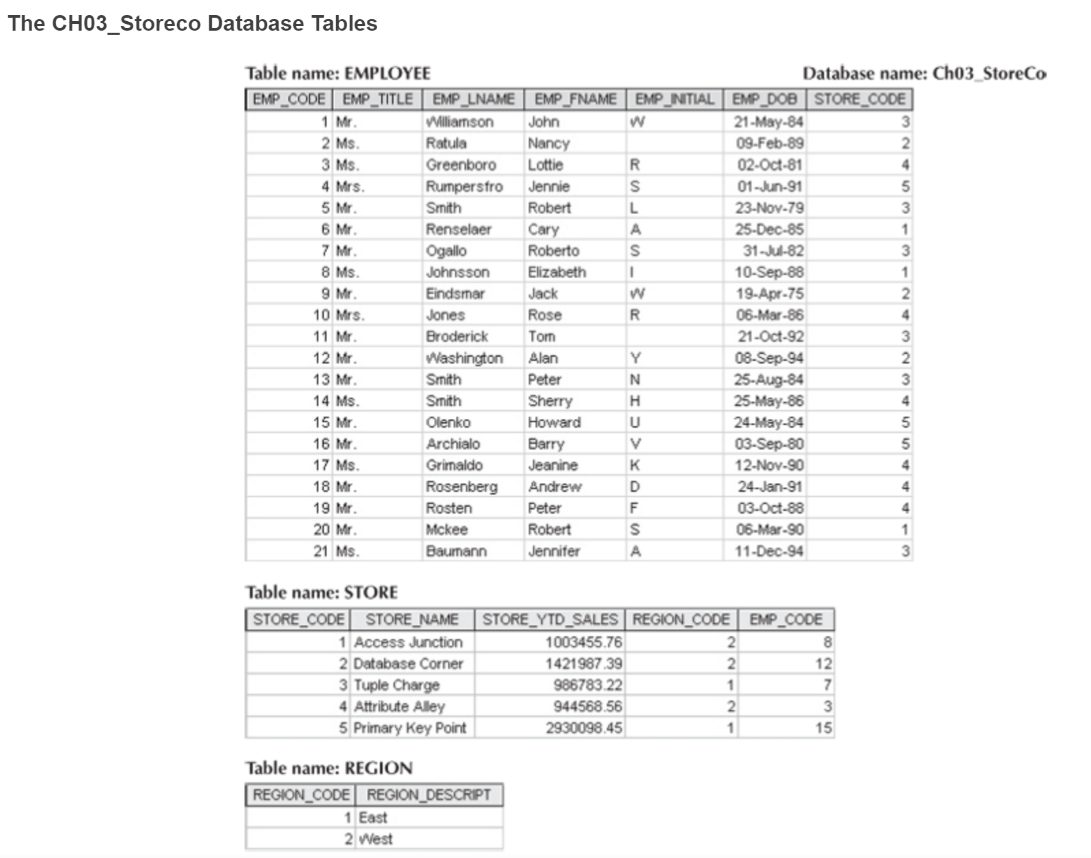

1. For each table, identify the primary key and the foreign key(s). If a table does not have a foreign key, write None.

* The primary key for employee table is **emp_code**. The foreign key is **store_code**.
* The primary key for store table is **store_code**. The foreign keys are **emp_code** and **region_code**.
* The primary key for region table is **region_code**. No foreign key(s).

1. Do the tables exhibit entity integrity? Answer yes or no, and then explain your answer.

Yes, the columns where primary keys are demonstrated, integrity is upheld, showing all unique codes for each row within every table.

And no, there are two null values displayed in the emp_initial column of the employee table, displaying lack of integrity.

1. Do the tables exhibit referential integrity? Answer yes or no, and then explain your answer. Write NA (Not Applicable) if the table does not have a foreign key.

Yes, the relationship between employee table and store table exhibits referential integrity where primary key emp_code and foreign key store_code is shown as logical connections to each other solely in employee table and store table.

This does not apply for region table since it does not have a foreign key.

1. Describe the type(s) of relationship(s) between STORE and REGION.

The type of relationship between store and region is “one to many”.

Since east and west regions can be separately tied to many stores.

A store cannot have many regions, it either is or isn’t located in one or the other region.

1. Describe the type(s) of relationship(s) between EMPLOYEE and STORE. (Hint: Each store employs many employees, one of whom manages the store.)

The relationship(s) between employee and store are “one to many”.

One store can employ many.

There can be other relationships such as “one to one” more specifically, understanding that one store employs only one store director.

1. 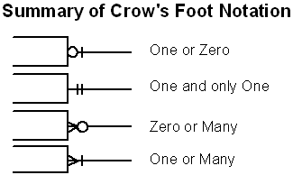Create the ERD to show the relationships among EMPLOYEE, STORE, and REGION. Use Lucid chart to create your ERD with crows foot notation. List any assumptions you make of how the business works to receive full credit! Please screenshot your ERD, paste it here, and upload this word document with your answers when you are done.

**Clarify**: The graph presents a relationship between one-to-many employees working at one but not only one store. In the event of an employee also working at two locations/ different store codes, this would apply.